St. Alban’s Episcopal Church
2848 St. Alban Drive, Sinking Spring, PA
Phone: 610-678-7001
www.stalbansepiscopal.org
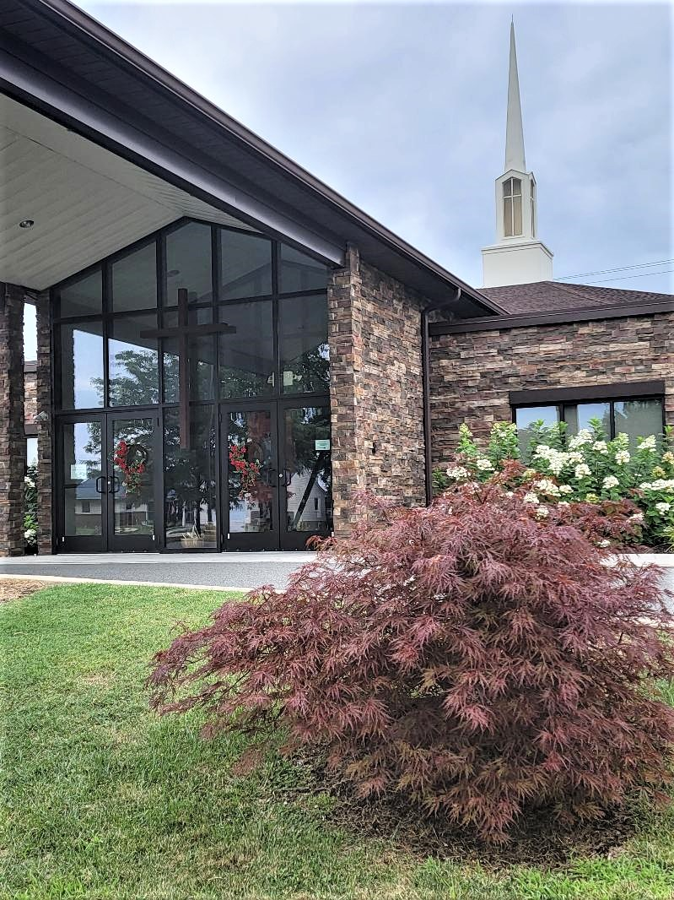

Sunday, April 28, 2024 | 8am & 10am
The Fifth Sunday of Easter
Welcome to St. Alban's!

It is a joy to have you with us on this Fifth Sunday of Easter.
Worship at St. Alban's currently follows the service for Holy Eucharist: Rite Two from the red Book of Common Prayer (BCP) in your pew. Hymns may be found in the blue book, The Hymnal 1982 (H). All page numbers in this bulletin refer to these two books.
Our service features music, readings from Holy Scripture, prayers, a sermon, and Holy Communion. (Music at the 8am service is omitted.) All baptized Christians are welcomed and encouraged to receive Holy Communion. If you do not want to receive Communion, you may come forward for a blessing if desired.
If you'd like to know more about St. Alban's or the Episcopal Church, one of our greeters can provide you with an information card, and we'll reach out to you soon.

We're glad you're here with us today, and again, welcome to St. Alban's!
The Holy Eucharist Rite II
(BCP refers to the red Book of Common Prayer)
Prelude “Renew with Strength Divine” Frederick Oakeley
Processional Hymn 379
“God is Love: let heaven adore him” Abbot's Leigh
Liturgy of the Word
The Opening Acclamation BCP p. 355
Collect for Purity BCP p. 355
Gloria (Hymnal S278) BCP p. 356
The Collect of the Day
Almighty God, whom truly to know is everlasting life: Grant us so perfectly to know your Son Jesus Christ to be the way, the truth, and the life, that we may steadfastly follow his steps in the way that leads to eternal life; through Jesus Christ your Son our Lord, who lives and reigns with you, in the unity of the Holy Spirit, one God, for ever and ever. Amen.
First Lesson Acts 8:26-40
An angel of the Lord said to Philip, “Get up and go toward the south to the road that goes down from Jerusalem to Gaza.” (This is a wilderness road.) So he got up and went. Now there was an Ethiopian eunuch, a court official of the Candace, queen of the Ethiopians, in charge of her entire treasury. He had come to Jerusalem to worship and was returning home; seated in his chariot, he was reading the prophet Isaiah. Then the Spirit said to Philip, “Go over to this chariot and join it.” So Philip ran up to it and heard him reading the prophet Isaiah. He asked, “Do you understand what you are reading?” He replied, “How can I, unless someone guides me?” And he invited Philip to get in and sit beside him. Now the passage of the scripture that he was reading was this: “Like a sheep he was led to the slaughter, and like a lamb silentbefore its shearer, so he does not open his mouth. In his humiliation justice was denied him. Who can describe his generation? For his life is taken away from the earth.” The eunuch asked Philip, “About whom, may I ask you, does the prophet say this, about himself or about someone else?” Then Philip began to speak, and starting with this scripture, he proclaimed to him the good news about Jesus. As they were going along the road, they came to some water; and the eunuch said, “Look, here is water! What is to prevent me from being baptized?” He commanded the chariot to stop, and both of them, Philip and the eunuch, went down into the water, and Philip baptized him. When they came up out of the water, the Spirit of the Lord snatched Philip away; the eunuch saw him no more, and went on his way rejoicing. But Philip found himself at Azotus, and as he was passing through the region, he proclaimed the good news to all the towns until he came to Caesarea.

Psalm 22:24-30
24 My praise is of him in the great assembly; *
I will perform my vows in the presence of those who worship him.

25 The poor shall eat and be satisfied,
and those who seek the Lord shall praise him: *
"May your heart live for ever!"

26 All the ends of the earth shall remember and turn to the Lord, *
and all the families of the nations shall bow before him.

27 For kingship belongs to the Lord; *
he rules over the nations.

28 To him alone all who sleep in the earth bow down in worship; *
all who go down to the dust fall before him.

29 My soul shall live for him;
my descendants shall serve him; *
they shall be known as the Lord's for ever.

30 They shall come and make known to a people yet unborn *
the saving deeds that he has done.

Second Lesson 1 John 4:7-21
Beloved, let us love one another, because love is from God; everyone who loves is born of God and knows God. Whoever does not love does not know God, for God is love. God's love was revealed among us in this way: God sent his only Son into the world so that we might live through him. In this is love, not that we loved God but that he loved us and sent his Son to be the atoning sacrifice for our sins. Beloved, since God loved us so much, we also ought to love one another. No one has ever seen God; if we love one another, God lives in us, and his love is perfected in us. By this we know that we abide in him and he in us, because he has given us of his Spirit. And we have seen and do testify that the Father has sent his Son as the Savior of the world. God abides in those who confess that Jesus is the Son of God, and they abide in God. So we have known and believe the love that God has for us. God is love, and those who abide in love abide in God, and God abides in them. Love has been perfected among us in this: that we may have boldness on the day of judgment, because as he is, so are we in this world. There is no fear in love, but perfect love casts out fear; for fear has to do with punishment, and whoever fears has not reached perfection in love. We love because he first loved us. Those who say, "I love God," and hate their brothers or sisters, are liars; for those who do not love a brother or sister whom they have seen, cannot love God whom they have not seen. The commandment we have from him is this: those who love God must love their brothers and sisters also.

Sequence Hymn 448
“O love, how deep, how broad, how high (vs. 1-3)” Deus Tuorum Militum

The Gospel John 15:1-8
Jesus said to his disciples, ”I am the true vine, and my Father is the vinegrower. He removes every branch in me that bears no fruit. Every branch that bears fruit he prunes to make it bear more fruit. You have already been cleansed by the word that I have spoken to you. Abide in me as I abide in you. Just as the branch cannot bear fruit by itself unless it abides in the vine, neither can you unless you abide in me. I am the vine, you are the branches. Those who abide in me and I in them bear much fruit, because apart from me you can do nothing. Whoever does not abide in me is thrown away like a branch and withers; such branches are gathered, thrown into the fire, and burned. If you abide in me, and my words abide in you, ask for whatever you wish, and it will be done for you. My Father is glorified by this, that you bear much fruit and become my disciples.”
The Sermon The Rev. Michelle Moyer
The Nicene Creed BCP p. 358
The Prayers of the People, Form IV BCP p. 388
Confession BCP p. 360
The Peace
Announcements
THE HOLY COMMUNION
Anthem “How Deep the Father's Love for Us” Stuart Townend
How deep the Father's love for us, how vast beyond all measure that he should give his only Son to make a wretch his treasure. How great the pain of searing loss. The Father turns his face away; as wounds which mar the Chosen One bring many sons to glory. How high, how wide, how deep the Father's love for us. Behold the man upon the cross, my sin upon his shoulders. Ashamed, I hear my mocking voice; call out among the scoffers. It was my sin that held him there; until it was accomplished; his dying breath has brought me life. I know that it is finished. How pure, how strong, how deep the Father's love for us. I will not boast in anything; no gifts, no pow'r, no wisdom. But I will boast in Jesus Christ: his death and resurrection. Why should I gain from his reward? I cannot give an answer. But this I know with all my heart: his wounds have paid my ransom. How high, how wide. How pure, how strong. How deep the Father's love for us.
Doxology Hymn 380 v.3 Old 100th
The Great Thanksgiving
Eucharistic Prayer B BCP p. 367
Sanctus (Hymnal S128) BCP p. 367
Lord’s Prayer BCP p. 364
Breaking of the Bread
Fraction Anthem (S155)
The Administration of Communion
We welcome all baptized Christians to partake of the Holy Communion at the Lord’s Table. We offer bread and wine, the wine is by intinction and Common Cup.
Communion Hymn 704 “O thou who camest from above” Hereford
The Postcommunion Prayer BCP p. 366
Blessing
Recessional Hymn 512 “Come, gracious Spirit, heavenly Dove” Mendon
Dismissal
Postlude “Honor, thanks and praise” John Wilton

+++

Participants in today’s Liturgy:

Celebrant………………………….……………The Rev. Michelle Moyer
8:00 am
Lector…………………………………………………......Nancy Daubert
Intercessor………………………………………………….Doris Sowers
10:00 am
Lector……………………………………………………...Kurt Hencken
Intercessor…………………………………………………...Alice Slisher
Acolyte/Server………………………………………………..Jack Lesher
Ushers/Greeters……………………………..Doris Maurer & June Dunn
Organist/Choir Director…………………………………...Mike Spangler
Altar Guild………………………Team A – Nancy Hughes & Jackie Beem
We welcome our visitors to St. Alban’s. Please introduce yourself to our clergy and join us for coffee and fellowship following today’s service.
The Sanctuary Lamp for April is given to the Glory of God by Peggy & Greg Odom in memory of John Wasiewski.
We give thanks to God for those in our community who are celebrating birthdays this week: for Jack Shimko and Rick Traffas; and for those who are celebrating anniversaries: David & Linda Shonk.

We remember in our prayers: Gerry, Eric, Fred, Alec, Richard, Norene, Joan, Kathleen, Nancy, Lisa, James, Jackie, Jameson, Joyce, Jan, Gayle, Lily, John, and Beverly.

Upcoming Events:
FLEA MARKET: Saturday, May 4, 7am – 1pm. Please save items to donate. Drop off items after 10am service. Sign-up sheets for volunteer opportunities or to bake cookies are on the Narthex bulletin board. To reserve a Flea Market space call Carol Reid: 610-781-5164.
Flea Market Spring Flower Sale: Pre-orders due by the 28th, with payment. Order forms are in the Narthex.
An Evening with George Gershwin, presented by Bob Kreitz. Held at St. Alban’s at 7PM on Friday, May 10th. Tickets are by donation - $10 suggested.
Reading Phillies Game: Sign up is in the Narthex for a Reading Phillies game on June 28th. Cost is $14 per person. Please sign up and pay by June 2nd. Checks payable to St Albans, please leave in Kurt's mailbox.
EyeGlass Donations: St. Alban’s is working with the International Lions Club as a collection site for used eyeglasses. Please drop off used eyeglasses in the narthex (broken glasses are accepted and will be repaired) and, if you have one, a case for the glasses. Glasses will be repaired and shipped internationally to those in need.
Pentecost Flowers: Pentecost is on May 19th and we will have order forms available in the Narthex. Order forms are due in the office by May 12th.
In-Reach:
Sunday Morning Coffee: Please, additional help is needed to make coffee Sunday mornings, to clean up following social hour, and to bring snacks. Sign up on bulletin board to help.
Prayer Shawls: A reminder from the prayer shawl group: if you know of anyone in need of a prayer shawl who might be ill, grieving or struggling for some reason please contact a member of the group for one of our beautiful shawls!
In-Reach Committee: We are looking for more volunteers to coordinate meals for parishioners when a need arises. Contact Maureen Carr, mfcarr943@gmail.com for more information.
Prayer Chain – Need prayer?: We are establishing a prayer chain for those who would like regular prayer and for those who need immediate prayer when emergencies arise. If you are interested in participating, contact Maureen Carr, mfcarr943@gmail.com.
Outreach:
Baseballtown Dream League: Our next game is May 18th. Game starts at 9:15 but volunteers should be there by 9:00 at the latest. Location: Savage 61 Dream Field, 2816 Old Pricetown Road, Temple, PA 19560. If you are helping out please contact Chuck Hobart (chobart@gmail.com), so you can be updated for any last minute weather/game updates and sent a volunteer form. Form must be filled out prior to game.
Opportunity House: Join us on May 22nd to provide meals.
Little Library: Do you have new and/or gently used books you are looking to pass along? Feel free to drop off unwanted books in the box in the narthex.
St. Alban’s Reaches Out: St. Alban supports programs in our community through your generous donations. Currently, we are collecting the following:
- Wilson Area Food Pantry for non-perishable food items especially peanut butter, canned fruits, veggies, pasta, tomato sauces, & canned meats such as tuna, spam, or chicken. Please also consider donating peelers, can openers, cooking oils, powdered milk, and spices.
- Empty ink cartridges
- New & slightly used books for the Cops & Kids Program
- Toiletries & magazines for the Opportunity House
- Monthly items for the Learning Center. This month: Colored pencils.

This week at St. Alban’s:
Sunday, April 28
9AM Bible Study
9:45AM Sunday School
Saturday, May 4
7AM-1PM Flea Market
1PM Flea Market Clean Up

Monday through Friday – Opportunities to assist with Flea Market set up, pricing, and baking.

St. Alban’s Episcopal Church
“A welcoming Christ-centered community growing in God’s grace and empowered to share Christ’s love in the world”

The Rt. Rev. Kevin Nichols, Bishop of the Diocese of Bethlehem
www.diobeth.org
Staff:
The Rev. Michelle Moyer, Rector; 610-737-4808
rector@stalbansepiscopal.org
Michael Spangler, Organist and Choirmaster
music@stalbansepiscopal.org
Naomi Pauley, Administrative Assistant
office@stalbansepiscopal.org
St. Alban’s Christian Learning Center:
Michele Daubert, Director
michele@saclc.org
The Vestry:
2025: Steve Allen Jr. Warden, Chuck Hobart, Robin Lewars, Carol Reid
2026: Maureen Carr, Kurt Hencken, Sr. Warden, John Meharg
2027: Tracy Lesher, Robert Kreitz

2848 St. Alban’s Drive, Sinking Spring, PA 19608
(610) 678-7001
www.stalbansepiscopal.org
info@stalbansepiscopal.org
Office hours are Monday through Thursday 9:00am to 3:00pm

